CISP 41 Programming in C#

Project Evaluation Sheet
Student Name: ___________ Bryant Tunbutr ____________________ Project Number: _______3________
Project Name: _______BtunbutrProject3_____ Visual Studio Version: ___2008________
Date Due: ________11/1/12_____________ Date Turned In: _____11/1/12_____
Above to be completed by student
Points ( ____ Possible)
Correctness/Efficiency:

Output is accurate ____________

Meets all requirements ____________

Provide appropriate user interface ____________

Logic is efficient ____________

Documentation/Coding Style:
Project can be open from the submitted zip file ____________

Folder is present and contains all necessary project files (no extra files) ____________

Use required coding template ____________

Use proper naming and spacing ____________

Submit all requested information ____________

Test Cases:

List all required test cases ____________

Provide output forms for important test cases ____________

Other issues: ____________

Extra Credit: ____________

Timeliness: ____________

Project Score:

CISP 41 Programming in C#

Project specification

This software is intended to summarize, calculate, and display costs for repairs for Bryant’s Auto Repair Shop.

It is designed to be run in Visual Studio 2008 using the C# coding.

It uses user input including the selected part to be repaired and number of hours.

It displays total cost, summary, and provides information about the program with an about button.

Used in the project are arrays, methods, calculations, multiple forms including summary and about and splash.

CISP 41 Programming in C#

Project status

The project is completed and finalized..

CISP 41 Programming in C#

Sketch of user interface

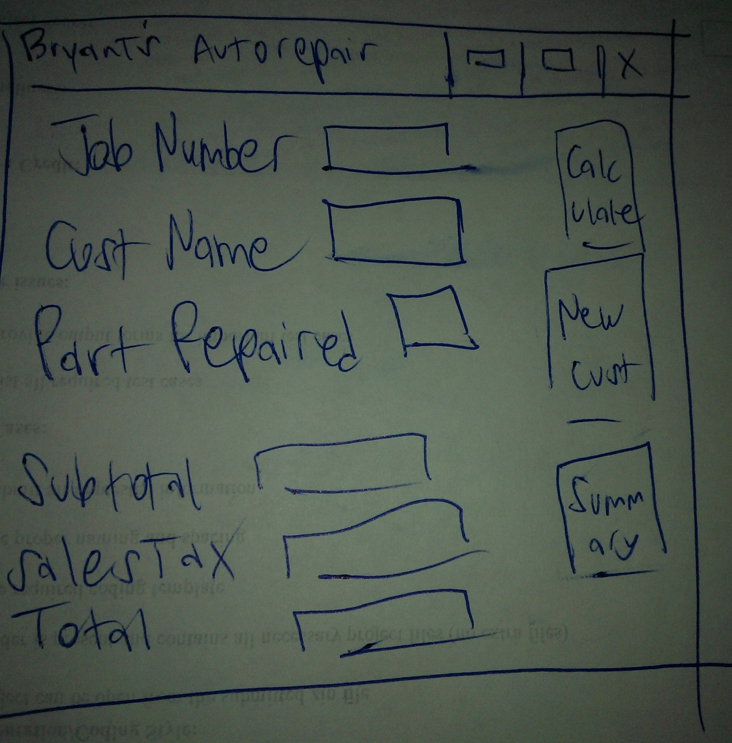

CISP 41 Programming in C#

Objects and Properties Plan for __ BTunbutrProject 3_________Form
Object | Property | Setting
exitButton | Name Text | E&xit
New Customer Button | Name Text | &New Customer
Subtotal | Text | Method
label | Name Text | Summary
Combo text box | Text | Drop down
about | Name Text | Info
BTunbutrProject3 | Name Text | Form
Menu | Name Text | Click
splash | Text | Form

CISP 41 Programming in C#

Event Plan for ___ BTunbutrProject 3________Form
Object | Event | Action - Pseudocode
summaryButton | Click | Call summaryButton_Click.  Display the price of the order.  Put new form up  Add to the number of orders and totalSales.  Reset the controls for the next order.  Clear the order amount
About | Click | Display the program info in a new form
aboutToolStripMenuItem | Click | Display a message box showing programmer and version
exitButton | Click | exit
Menu | Click | Buttons that are the same name
Drop down | Click | Select array

CISP 41 Programming in C#

Test cases and captured screens

Test case #1
Ab orders battery with 3 hours of labor
Bea orders engine with 11 hours of labor

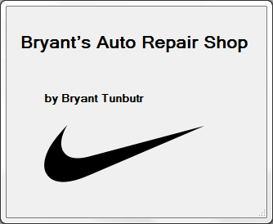

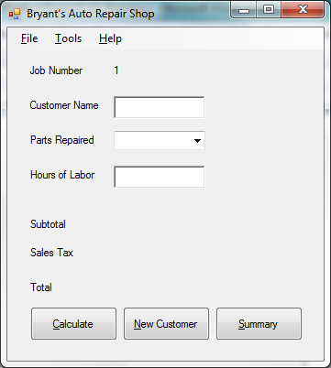

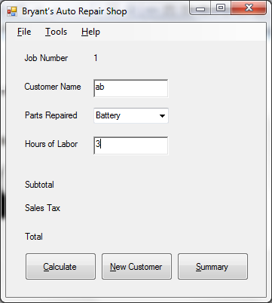

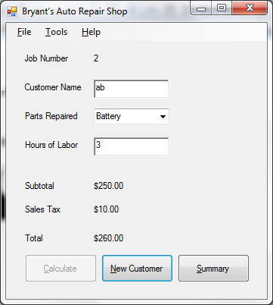

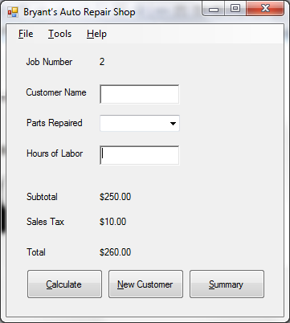

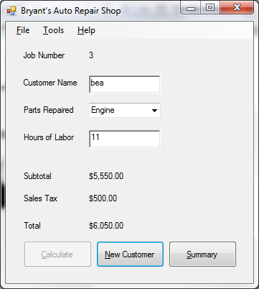

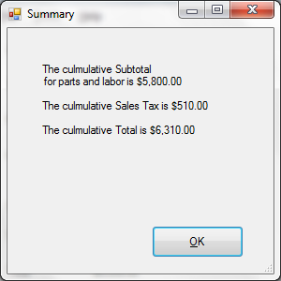

Test case #2
Missing and wrong data input

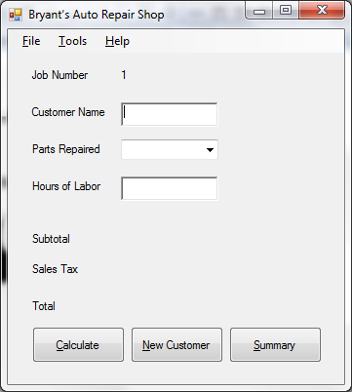

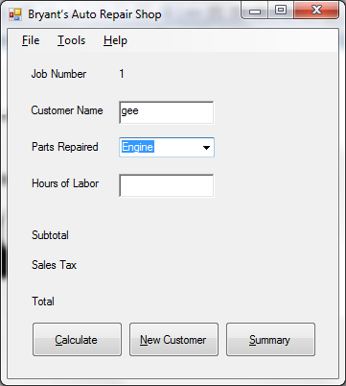

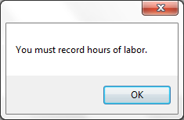

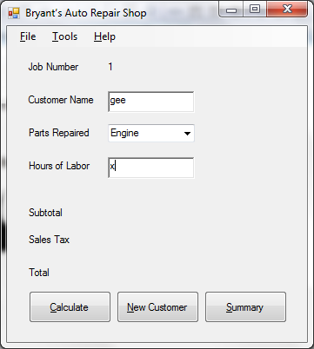

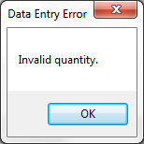

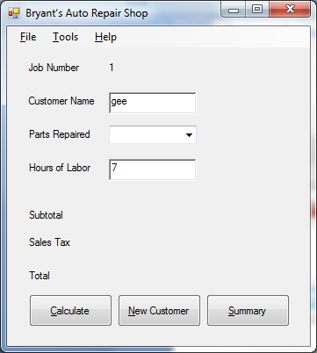

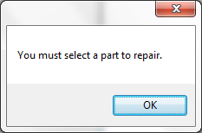

Test case #3
John, Jan, Joan each buy spark plug with 1 hour of labor each

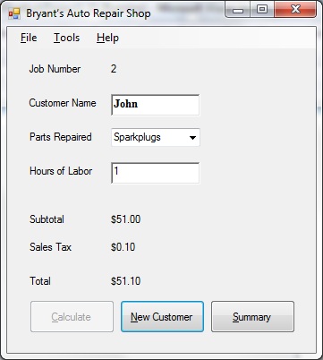

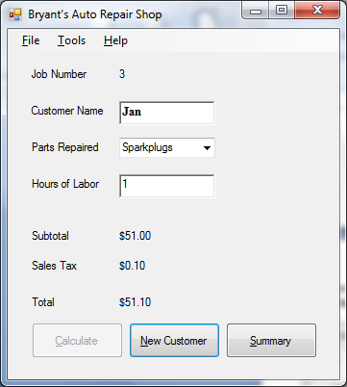

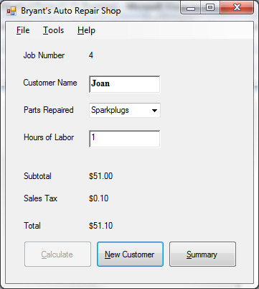

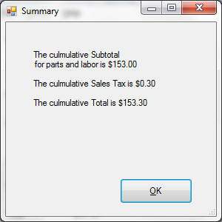

Test case #4
Mitch buys an engine that takes 10 hours
Then comes back and buys a battery that takes 3 hours

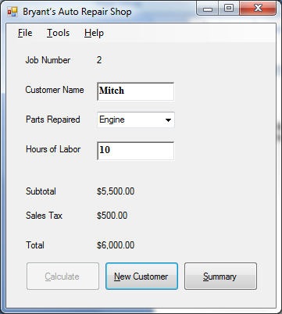

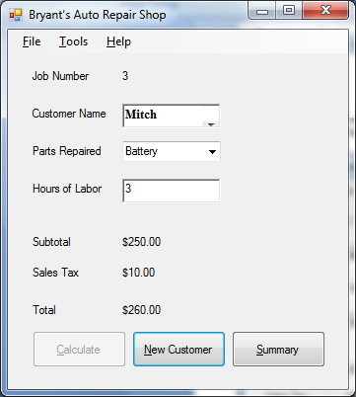

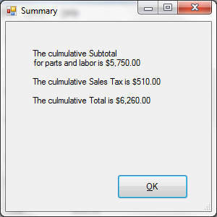

CISP 41 Programming in C#
Source code

Main form

/*
* Project: BtunbutrProject3
* Programmer: Bryant Tunbutr
* Date: Nov 1 2012
* Description: Calculates and displays the cost for autoshop materials and labor
* I certify that the code below is my own work.
*/

using System;
using System.Collections.Generic;
using System.ComponentModel;
using System.Data;
using System.Drawing;
using System.Linq;
using System.Text;
using System.Windows.Forms;

namespace WindowsFormsApplication14
{

public partial class Form1 : Form
{
public struct GroupInfo
{
//public string groupNumberString;
public decimal totalDecimal, groupNumberDecimal, totalsDecimal;
public int groupNumberInteger;
}

// Declare the variables.
decimal partsChargesDec, subTotalDec,
salesTaxDec, totalDec, laborChargesDec,
summarySalesTaxDec, summarySubTotalDec, summaryTotalDec;
int number, groupNumberInteger;

public Form1()
{
InitializeComponent();
//Intialize the variable to 1
number = 1;
//Intialize the label to 1 as well
jobLabel.Text = number.ToString();
}

private void calculateToolStripMenuItem_Click(object sender, EventArgs e)
{
}

private void exitToolStripMenuItem_Click(object sender, EventArgs e)
{
this.Close();
}

private void newCustomerToolStripMenuItem_Click(object sender, EventArgs e)
{
// clear boxes
customerNameTextBox.Text = "";
hoursOfLaborTextBox.Text = "";
groupComboBox.Text = "";

//set focus
hoursOfLaborTextBox.Focus();

//enable calculate
calculateButton.Enabled = true;
}

private void aboutToolStripMenuItem_Click(object sender, EventArgs e)
{
//show about form
AboutBox1 aboutForm = new AboutBox1();
aboutForm.ShowDialog();
}

private void jobLabel_Click(object sender, EventArgs e)
{
}

private void button1_Click(object sender, EventArgs e)
{
// Add the current item price and quantity to the order.

//check for missing info
if (groupComboBox.SelectedIndex == -1)
{
MessageBox.Show("You must select a part to repair.");
}
if (hoursOfLaborTextBox.Text == "")
{
MessageBox.Show("You must record hours of labor.");
}
else
{
try
{
//calculate by using what customer selected, match with prices here
groupNumberInteger = groupComboBox.SelectedIndex;
switch (groupComboBox.SelectedIndex)
{
case 0:
partsChargesDec = 100m;
break;
case 1:
partsChargesDec = 5000m;
break;
case 2:
partsChargesDec = 1m;
break;
case 3:
partsChargesDec = 50m;
break;
}

decimal hoursOfLaborDec = decimal.Parse(hoursOfLaborTextBox.Text);

// Calculate values.
salesTaxDec = partsChargesDec * .1m;

laborChargesDec = hoursOfLaborDec * 50m;

subTotalDec = partsChargesDec + laborChargesDec;

totalDec = subTotalDec + salesTaxDec;

//Display the results
salesTaxInfoLabel.Text = salesTaxDec.ToString("C");
subtotalInfoLabel.Text = subTotalDec.ToString("C");
totalInfoLabel.Text = totalDec.ToString("C");

//Increase job number, increment the number
number++;
//Update the label. Convert the number to a string
jobLabel.Text = number.ToString();

//disable calculate
calculateButton.Enabled = false;

// running total of sales tax, subtotal, total for all customers
summarySalesTaxDec += salesTaxDec;
summarySubTotalDec += subTotalDec;
summaryTotalDec += totalDec;
}
catch (FormatException)
{
// Error message for bad info.
MessageBox.Show("Invalid quantity.", "Data Entry Error");
}
}
}

private void summaryButton_Click(object sender, EventArgs e)
{
// Display the summary form.
SummaryForm aSummaryForm = new SummaryForm();

// send info to the summary form.
aSummaryForm.SummarySubTotal = summarySubTotalDec;
aSummaryForm.SummarySalesTax = summarySalesTaxDec;
aSummaryForm.SummaryTotal = summaryTotalDec;

// make modal summary form.
aSummaryForm.ShowDialog();
}

}
}

Summary form

using System;
using System.Collections.Generic;
using System.ComponentModel;
using System.Data;
using System.Drawing;
using System.Linq;
using System.Text;
using System.Windows.Forms;

namespace WindowsFormsApplication14
{
public partial class SummaryForm : Form
{
// make values accessible to this summary form

decimal summarySubTotalDec,summarySalesTaxDec,summaryTotalDec;

public decimal SummarySubTotal
{
set
{
summarySubTotalDec = value;
}
}

public decimal SummarySalesTax
{
set
{
summarySalesTaxDec = value;
}
}
public decimal SummaryTotal
{
set
{
summaryTotalDec = value;
}
}

public SummaryForm()
{
InitializeComponent();
}

private void Form2_Load(object sender, EventArgs e)
{
// display summary
summaryLabel.Text = "The culmulative Subtotal" + "\r\n" + " for parts and labor is " +
summarySubTotalDec.ToString("c") + "\r\n" + "\r\n" +
"The culmulative Sales Tax is " + summarySalesTaxDec.ToString("c") + "\r\n" + "\r\n" +
"The culmulative Total is " + summaryTotalDec.ToString("c");
}

private void okButton_Click(object sender, EventArgs e)
{
this.Close();
}
}
}

